Contents

How Java script is executed 2

Memory 2

Code 2

JS is a Synchronous single threaded language 3

What happens when java script is executed. 3

Memory allocation phase 4

Execution phase: 4

Hoisting in JS 6

Function invocation 6

This 7

Undefined – not defined 8

Lexical environment 8

Let and Cons 11

Block Scope 12

Shadowing 14

Closures 17

Settimeout + clousers 19

First class functions 21

What are parameter and arguments. 23

What are first class params 23

Arrow functions 24

CallBack functions 24

JS Engine 31

JS engine Architecture 31

parsing 31

Compilation: 33

Execution 33

Setimeout issues 34

Higher order functions 37

Map, filter, reduce 40

Callback Hell 46

Inversion of control 48

Promise 48

How to create promise 54

Promise chaining 59

Promise APIs 60

Async await 66

Async 66

Fetch 70

# How Java script is executed

Everything in JS happens in execution context.

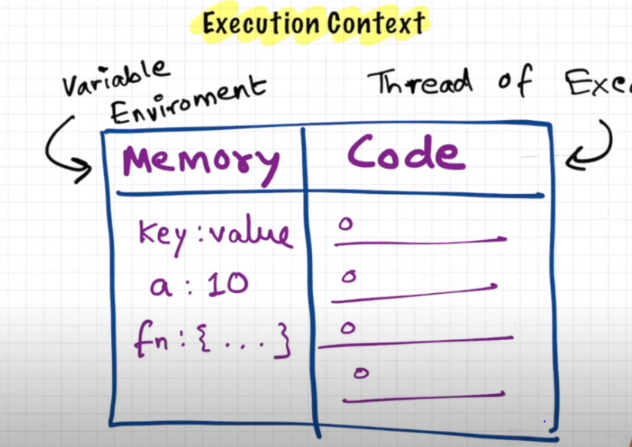

Every Js executes in Execution context. In this it has two blocks. First one is Memory or variable environment. And second one is Code.

## Memory

In memory block all the variables are stored as key value and functions are stored in this memory area.

## Code

Code area is also called as Thread of execution. All the code is available here and executed line by line.

# JS is a Synchronous single threaded language

It means JS can execute single line at a time so it is called as single threaded language. And once the single command is completed fully then only it can go to second command. It will wait till the first command is completed. Because of this it is synchronous. As JS executed line by line and waits until the one command is completed so it is called as single-threaded synchronous language.

# What happens when java script is executed.

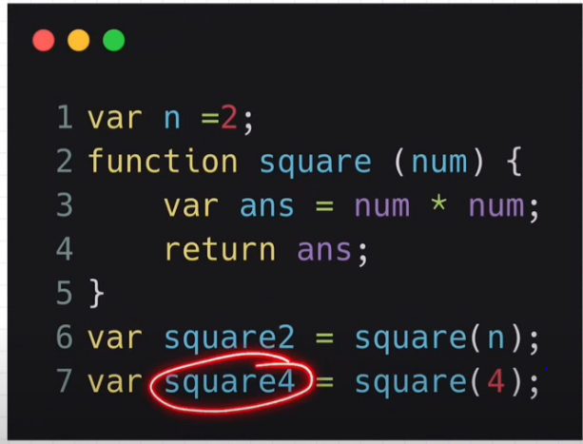

It has two phases. Memory allocation phase and code execution phase.

## Memory allocation phase

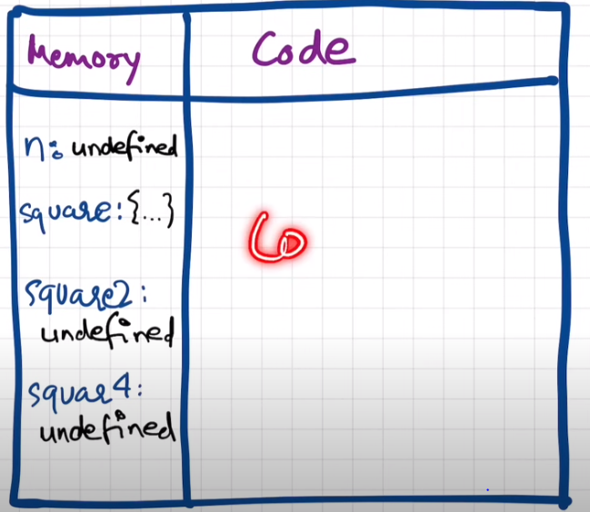

In this phase JS will skim through the whole code and allocates the memory. For variables it will allocate the memory and undefined is stored in that. And memory for functions are allocated and the whole function code is stored in that memory.

## Execution phase:

It executes line by line. When first line is executed then it will assign the value 2 to the memory allocated in memory area. And second command is just function declaration and nothing is done.

Next command is calling the function. So here it will invoke the function.

In JS when ever a function is invoked then it will create a new execution context for this function

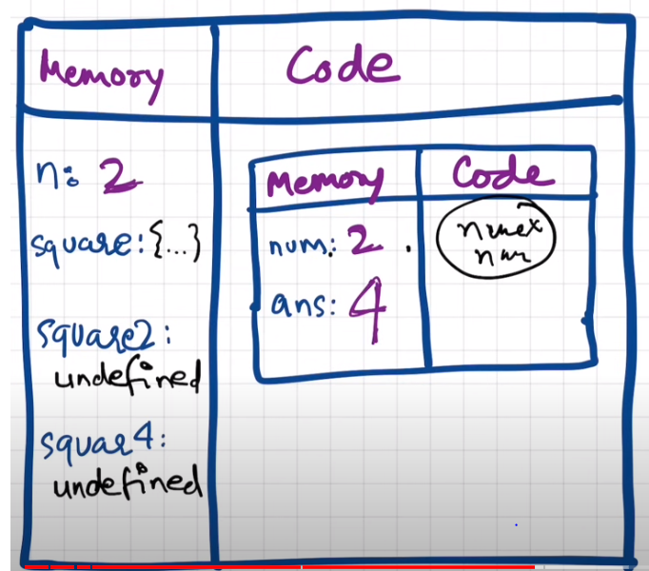

And as new execution context is created then again it will follow the same process as memory allocation and code execution.

Once return is triggered then control of the program will be returned to the old execution context from where it is called.

Once the whole function is completed then the execution context will be deleted.

Once all the code is completed the global execution context will also be deleted.

All these execution contexts are maintained in stack. As stack is first in last out. When first execution context is created it places it in stack and when even new context s created it ill goes on adding to stack. Once context is completed then it will remove context from the stack.

# Hoisting in JS

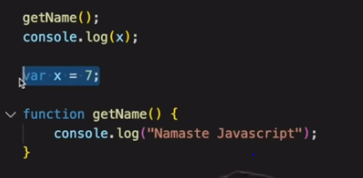

In above example x is used before it is initialized and getname() is called before it is declared.

Hoisting in js is that we can access the varables and functions even before variable is initialized and function is not declared.

# Function invocation

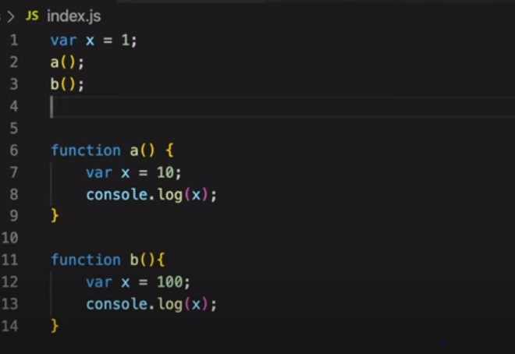

Here x is global viariable and also used in both functions. How will that work and behave.

While executing above code first globalexecution context will be create and in that value of x id defined. And when a function is called then another execution context will be created and value x is defined in that context and same way for B function one more execution context will be created. So here there is no link between the three executuion contexts. And what ever we change values it will be in that context only. So output of above code is

10

100

1

# This

Even if we execute the empty JS file then a global execution context will be created. By default JS will create lot of functions in the global space and those can used anywhere in the JS code written by us.

By default JS will create global execution context and global object called as window.

To run the JS code these must be JS engine. All the browsers will have there own JS engines. And in browsers the global object created is called as window. And in other server like node its name will be different and is different in different servers.

So this same as window object in JS.

All the global objects or functions in the JS file will be linked to the window object.

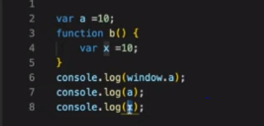

So we can access those functions or variables using window objects as shown above.

If window is defined at starting then it means it is refering to the global objects. And same way if we didn’t add anything before the variable like in above example .log(a) then it will automaticlly refer to the global object.

And same way this also refer to global object

SO this or window or nothing will be referenced to global object.

# Undefined – not defined

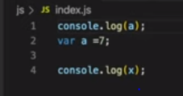

In this case as a is accessed before it is defined. So as memory is allocated for a and undefined is stored in a so when we log a before it is initialized then it will give undefined.

But the variable x is not defined any where in code and when we try to access it then it will give not defined.

Once a variable is created we can assign any value in that variable as shown below. So JS is called as loosely coupled language.

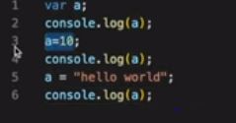

# Lexical environment

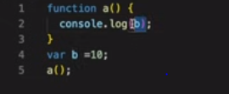

This will print 10

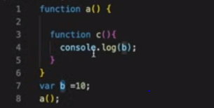

This will also print 10

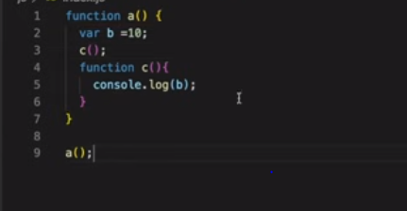

This will even print 10.

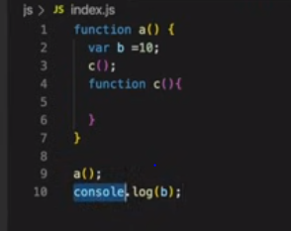

This will say b is not defined

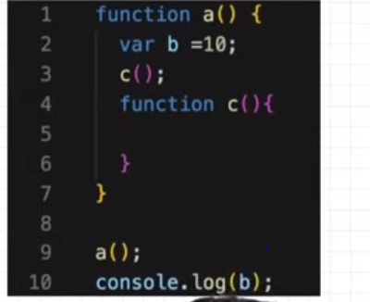

Stack of above code is created as below.

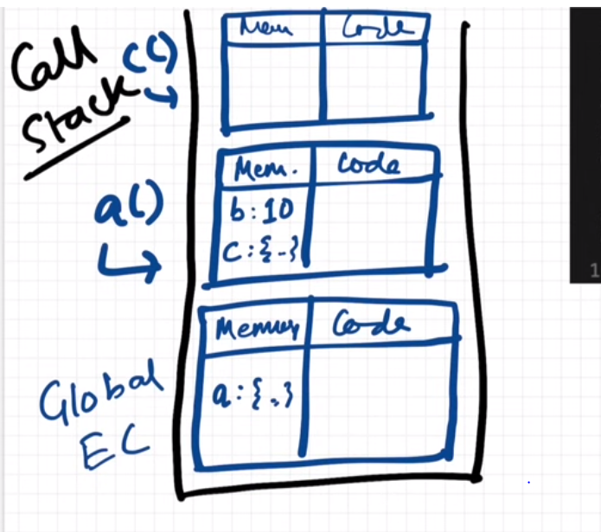

SO when ever a executor context is created a lexical environment is created. So lexical environment is combination of local memory and lexicalenvironment of parent executor and lexical env of parent is same as its local memory and lexical env of its parent and its goes on till the global executor. It means basically memory of parent can be accessed by all the child executors.

The process of the chain of the lexical environments ie going from child to parent and parent to its parent is called as scope chain.

# Let and Cons

These let and cons are also hoisted.

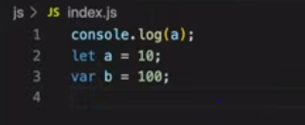

In above case when we try to access b(declared as var) before declaring it will print as undefined because of hoisting.

But same if we try to access the variable a(declared as let) before declaring it will give cannot access a before initialization.

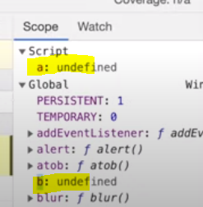

Before starting the code execution. A was defined under script and b was defined in global.

Incase of let and const also memory will be allocated(hoisting) but will be save in another memory and cannot be accessed before putting some value in that .so it tis giving cannot access a before initialization.

Temporal dead zone – the time from the variable let or const are defined and till the value is allocated to that variable is called as temporal dead zone.

The time from hoisting the let variable to assigning some value in it called as temporal dead zone.

And if a variable is in temporal dead zone and you are trying to access that variable then it will give referenceError - cannot access a before initialization.

When variables are In temporal dead zone then we can not access the variable. It can be access only when value is assigned to that variable.

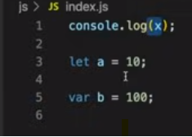

In above case x is not defined in the code so when we try to access the x it will give x is not defined.

In above case if instead of x if we try to access the b then it will give undefined because of hoisting. Memory was allocated but not initialized.

In above case if same instead of x if we try to access the a then it will give cannot access a before initialization. – because it is in temporal dead zone.

When variable is declared a var then it will be assigned to window object. But if variable is declared as let and const then those will not be assigned to window object.

Now if once let a is defined and if same let a is declared again in code like duplicate then it will give syntaxerror identifier a has already been declared.

Same way if let a is declared and next trying to declare var a again then also it will syntaxerror identifier a has already been declared.

But if var a is declared and trying to declare var a again then it wont give any error.

Let and const are same but only difference is while declaring let we can just declare and initialize the variable later in the code. But const is like while declaring only we need to initialize the value. It is like constant.

Once value is assigned to const and again in the code later trying to assign some value to const variable then it will give typrerror.- Assignment to constant variable.

# Block Scope

Block is basically from starting bracket to end bracket

{

}

So in a block we can add multiple statements. Group of multiple statements is called as block.

All the variables and functions that can be accessed in that block is called as block scope.

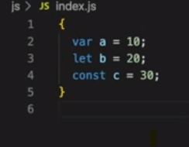

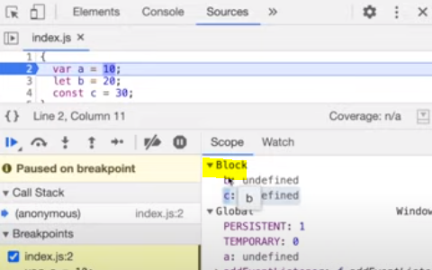

In above case when a variables are declared in the block then a separate memory named as block will be created variables are stored in that memory.

When var, let and const are declared in block then memory will be created for var in global memory and memory will be allocated for the let and const in block memory. So let and const are called as block scoped.

And those let and const cannot be accessed out side the block scope. Because they are defined in block scpope.

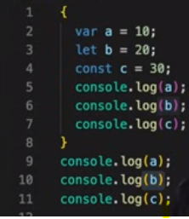

This code will give error when line 10 is executed.

# Shadowing

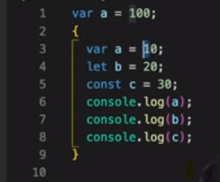

If a variable is declared outside and same variable is declared in the block then block variable shadows the outer variable.

In above case line 6 will be printed as 10. Because it is shadowing th outer variable.

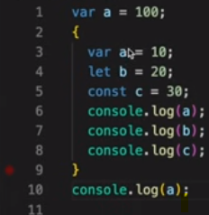

In above case at line 10 even we are trying to access the a in outer scope it will print 10. Because in both cases outer or inner block for a var only one space is allocated in memory. And when line 1 is executed then it will assign the value 100 and when line 3 is executed then value 10 will be assigned in the same memory and this is called as shadowing. And now when we try to access that at line 10 it will print 10 because 100 got replaced by 10 at line 3.

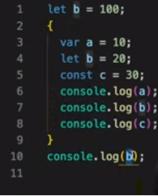

In above we are shadowing the b. but let variables when declared in block are stored in block scope and the le variables which are declared at outside are stored in other memory so both are refering to different memory.

So even at line 4 b got changes it wont effect the variable b declared at 1. And line 10 wil print 100.

Same will happen for const.

And the shadowing will function same way in function block also.

Illegal shadowing:

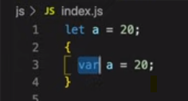

Here outer scope variable is declared as let and trying to make it as a var in block scope then it is called as illegal shadowing. And it will give a variable is already declared.

Shadow let using let is possible. Let using var is not possible. And var using let is possible.

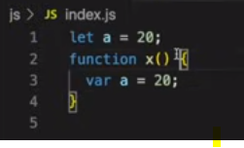

This is valid but below one is not valid



Because in first case var a is in function scpope. So both are in different scope and memory is created in different spaces.

# Closures

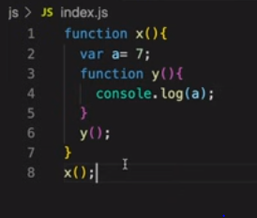

This will print 7 at console.

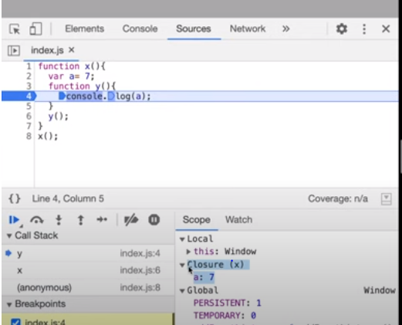

Function along with lexical scope is called as clouser.

A function can be passed as a variable to a function and a function can also be returned in a function.

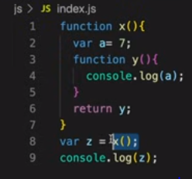

In above case Y has access to lexical env of x so that function y can print a because it has access to a.

Now when y is returned as a function then at line no 8 z contains the function y. and line 8 is outside the function x. it means ideally it wont have access to the lexical env of x. now what happens if we try to execute z. what will it print.

But the returned function will remember the lexical scope which it has previously. So when line 8 z is executed thn it will xecute the y function and will display 7 in the log.

So when a function is returned then it will return lexical scope + function it means clouser will be returned.

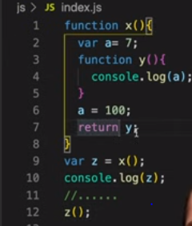

This will print 100 because lexical scope is returned and it got updated.

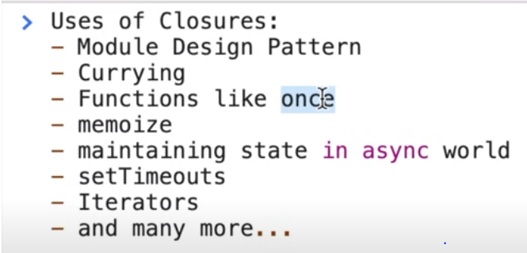

# Settimeout + clousers

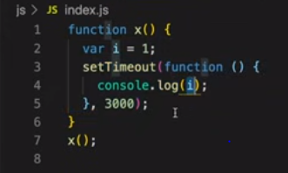

This will print the I after 3 sec.

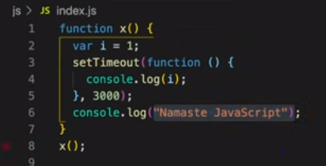

Every one thinks that as JS is synchronous so line 6 will wait until settimeout is executed.

But it will not happen like that because settimeout wil not executed at that line.

In above case as function is passed as a variable for settimeout. Then it will carry the lexican scope also with that. It means it will pass clouser. Now the settimeout will carry that function and places at some memory and wwill continue the JS code. And after 3 sec it will execute the function passed in timer. Because of this Namasthe javascript is executed before printing the i.

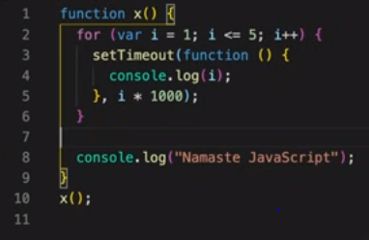

This will print Namasthe java script and 6 6 6 6 6.

But we expected that it will print namasthe javascript and print 1 2 3 4 5 for every second.

Here as function passes into settimeout It will also pass the lexical scope of that function. So when for I =1 we passed then it will pass the lexical scope with I value as 1. And now the loop is continuously running and the value of I is increasing and changed to 6 and lexical scope is updated to 6 and now all the functions passed to settimout will be referring to same lexical soce so it is printing 6 6 6 6 6.

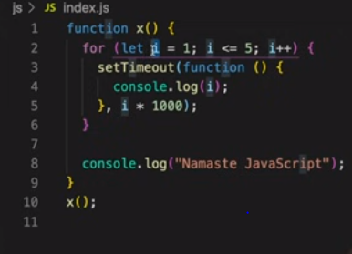

Use let instead of var. because every time let will create block scope everytime . and will not be updated with oother functions.

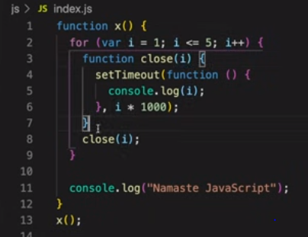

if same thing want to be achieved with var then use above code.

# First class functions

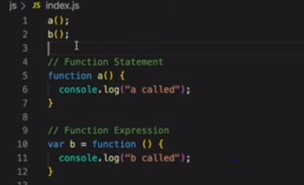

First type of declaration is called as function statement . second type of declaration is function expression.

In both cases we have called then before they are declared. But here hoistng will come into picture.

In first case while scanning the JS file function a will be added to the memory so it can be accessed before it is declared.

But for second case as we are assigning the function to the variable. And while scanning the js file a memory with undefined is created for the var b. so if we try to access the b before it is declared then it will give typeerror b is not a function.

Function declaration and function statement both are same.

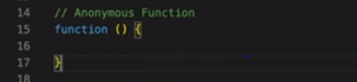

Anonymous function means function with no name. but we cannot create anonymous functions it will give error. Syntax error function statement requires function name.

So Anonymous functions are used in JS as values. It means when we need to pass the function into a other function or if you need to assign function to a variable then we can use anonymous functions.

Named function expression is like same as expression. But the expression with name.

Expressions can be declared using anonymous functions as below



But if expression is declared with name then it is Named function expression as below.

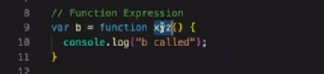

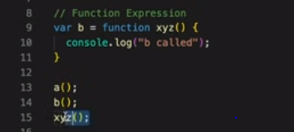

When named function expression is declared and if yu try to access the function with name then it will give reference error xyz if not defined. Because xyz function is a value .

## What are parameter and arguments.

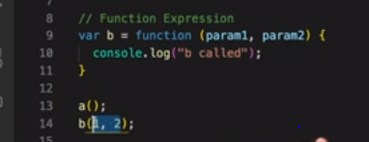

In above example the values which are passed into the function at line 14 (1,2) are called as arguments. And the values defined at line 9 are called as parameters, param 1 and param2.

## What are first class params

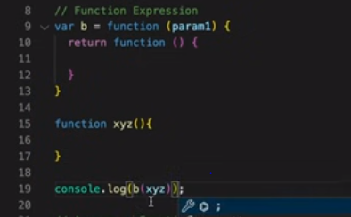

In Js we can pass function as a argument as shown in line 19. And we can also receive function as a parameter as line 9 and we can also return function as line 10.

All the above abilities to use function as argument or parameter or return is called as first class functions.

## Arrow functions

## CallBack functions

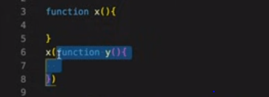

The function which is passed as a argument is called as call back function. In above case y is a call back function.

It is like y can be called back after some time.

+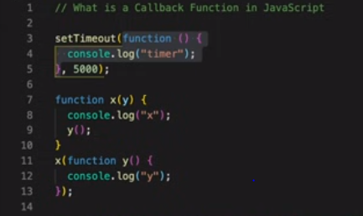

Example to use call back function.

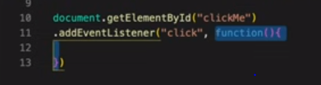

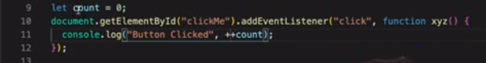

Example to count no of time a button is clicked. But there problem is count will be available in global scope. So it can be updated from any other code functions.

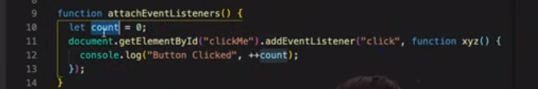

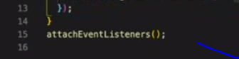

In above case. When attacheventlistenr is called then a separate lexical scope will be created for that block and when xyz is passed then lexical scope of that block will be passed and it will remember the values. But no one can be update the value from outside of this lexical scope.

**Why does eventlistners should be removed.**

Because these are heavy, so when eventlistner is called a clouser is created which contains the memory of parents and global. Because of this listners should be removed.

As java script is synchronous what ever comes into call stack it will execute. So we cannot make some thing to wait and execute later.

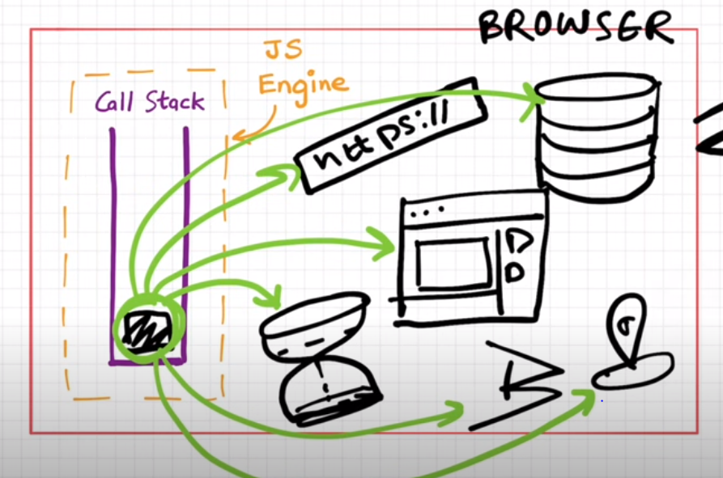

Browser has many features like timer, display, connect to other services and get data. To use all these services ,call stack should connect to all these services because JS code will be executed through the call stack.

To connect to those services we have webapis.

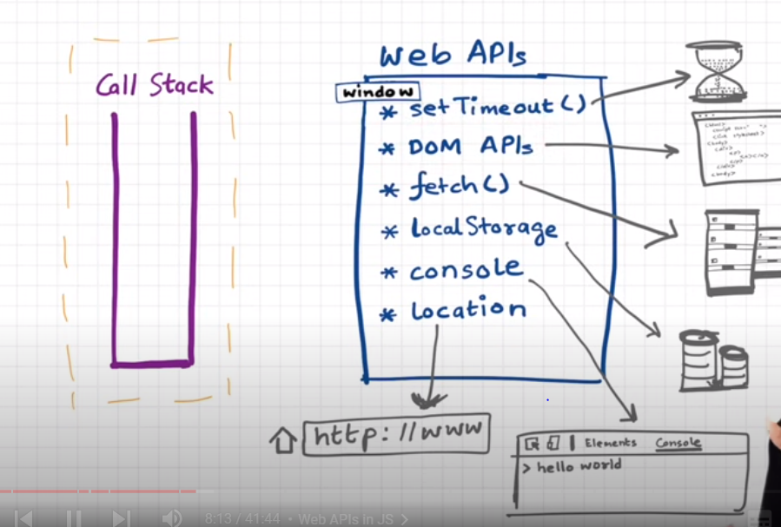

All these are part of browser.

All these will be available in global object called as window.

So if need to use timer then use, window.settimer, window.localstorage etc.

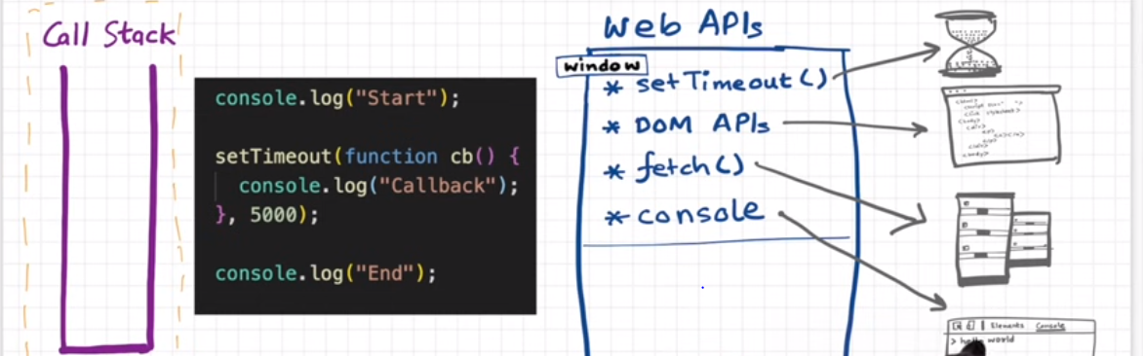

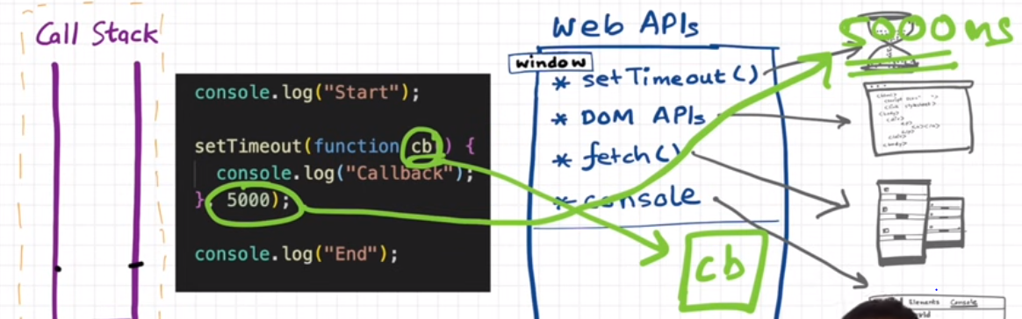

Here when settimeout is called, it will call browsers settimeout. And saves the callbackfunction as shown above. And the timer will be set as 5000.

Now for a function or something to execute it should be available in callstack. But the code execution is completed and all the items from the call stack are removed. So to execute the timer callback function that callback function should be moved to call stack and how it is moved.

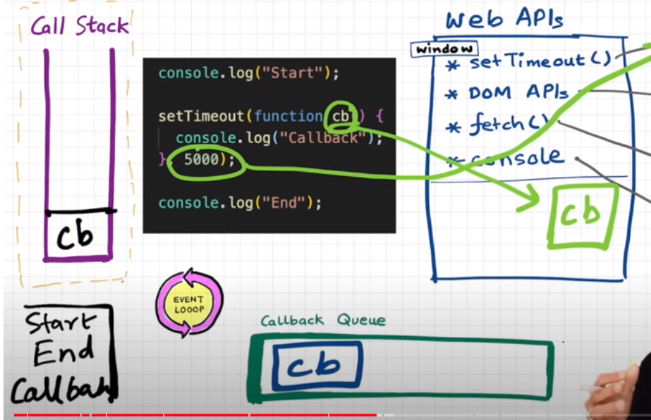

So when time is finished its time then its time to execute the cb function. Now when time is finished then the callback function is moved to the callbackqueue and the event loop here will act as gatekeeper and moves the callbackfunction to the call stack.

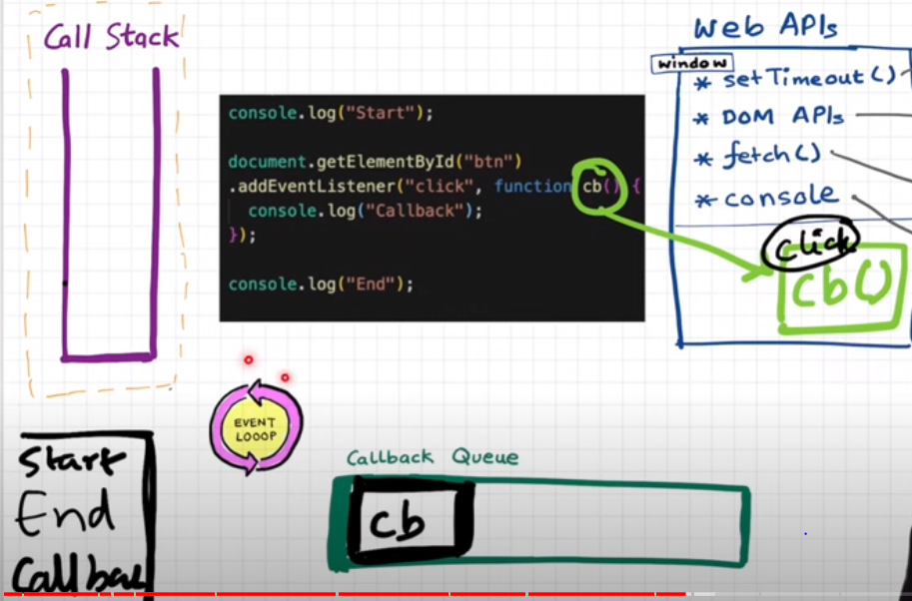

Event loop job is to monitor the call stack and callbackqueue. If callstack is empty and if there are any functions in queue then add the function to call stack.

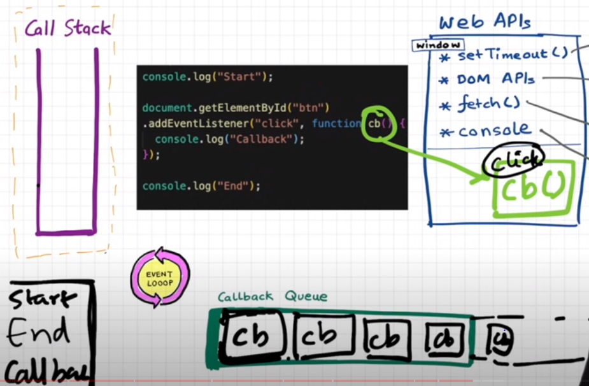

When multiple times button is clicked then multiple times function is pushed into queue.

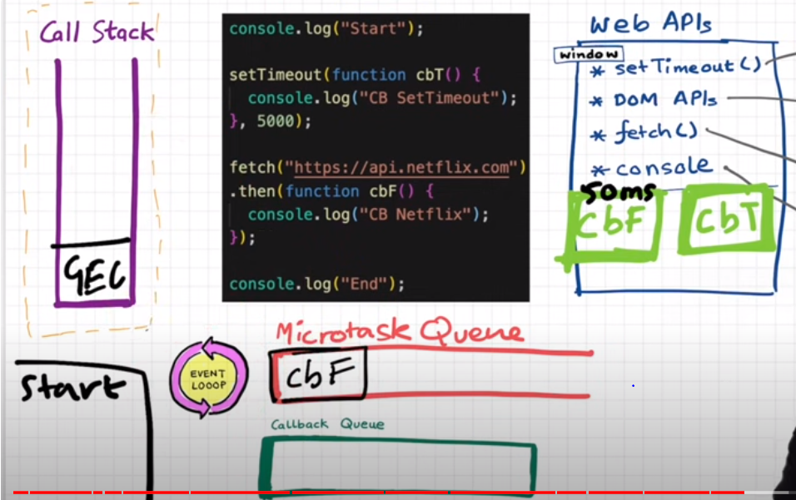

In case of fetch it will work differently.

Here we have another queue called as microtask queue. It has more priority then the call bac queue.

Again the process is same. Eventloop will monitor the callstack. When callstack is empty then it will push the cbf into call stack because microtaskqueue is thee hgh priority queue. And once cbf is done then agaon cbt willlbe pushed.

The callbackfunctions which generated by prmises and mutationfunctions(Dom changes

) will be going to microtask queue.

Starvation of callback queue

So if there is one callback function in microtaskqueue and that callback function is generation more callbackfunctions then the functions in microtask queue will be increasing. So the callbackfunction which is available in callback queue will not get the chance to execute and this is called as starvation of callbackqueue.

## JS Engine

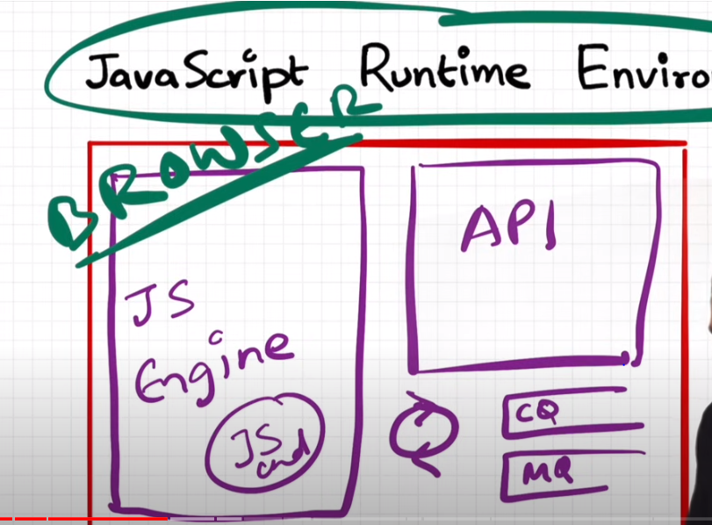

First javascript engine is developed and known as spider monkey.

## JS engine Architecture

Js engine is a normal code.

JSengine takes the code which we write.

1.parsing

2. compilation

3. execution

### parsing

tokens - during this phase the code which we write will be break into the tokens.

For example let a = 7

In this case let is atoken and a is a token and 7 is a token.

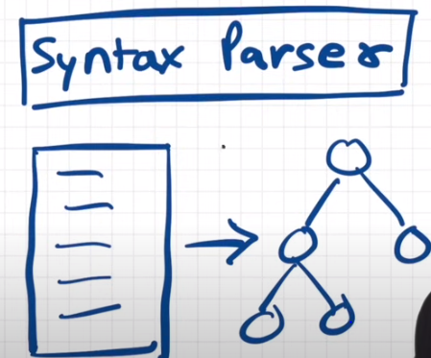

Syntax parser will take the code as input and convert into the AST – abstract syntax tree.

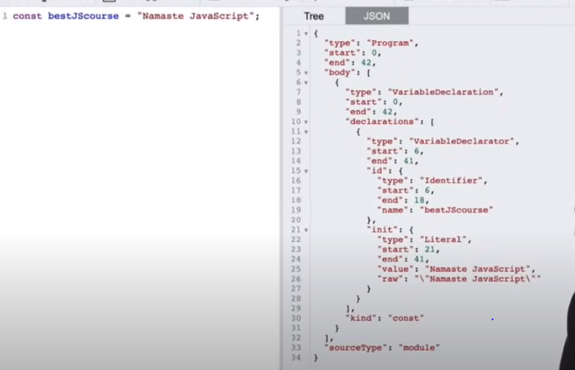

For the above left side code the syntax parser will generate the AST as right side.

Astexplorer.net is the site to explore AST.

The output of the parsing is the AST and this AST will be given as a input to the compilation phase.

### Compilation:

Javascript is a interpreted language.

Java script uses JIT compilation.

In js engine AST is given as input to interpreter. And interpreter interprets the AST code line by line and moves to execution stage. but while code is interpreted compiler is also used. So compiler will talk to interpreter to optimize the code. The compiler will generate the bytecode.

And this process of both compiler and interpreter is called as JIT.

### Execution

It contains the call stack and memory heap.

All the memory is stored in memory heap. It is the space where all the variable are stored.

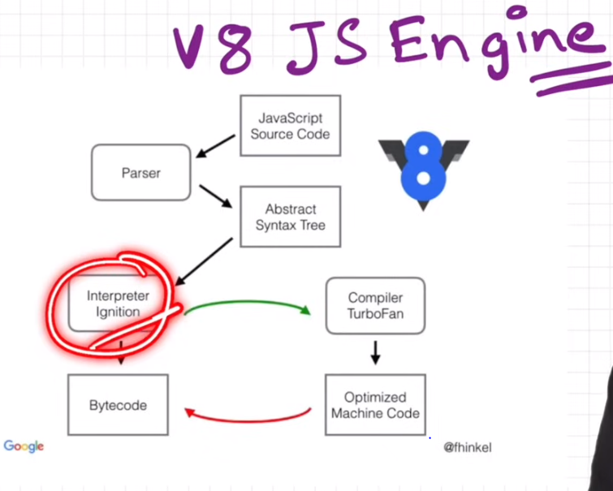

## Setimeout issues

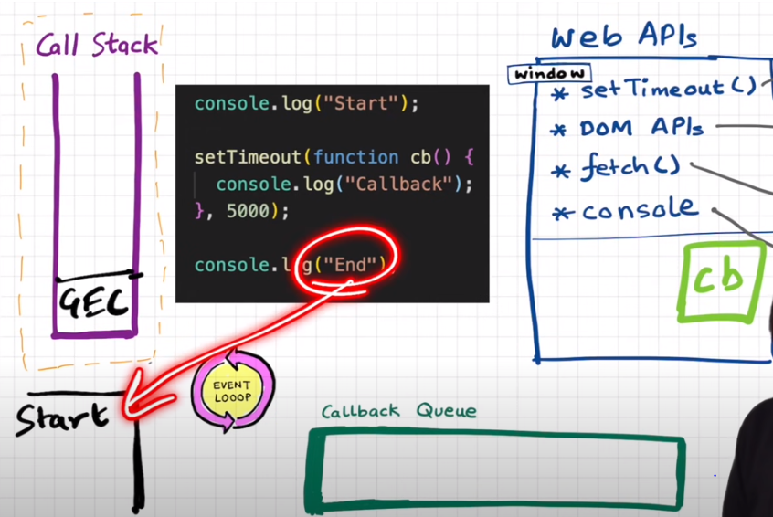

Once timeout is happened then the CB function is pushed into the callback queue.

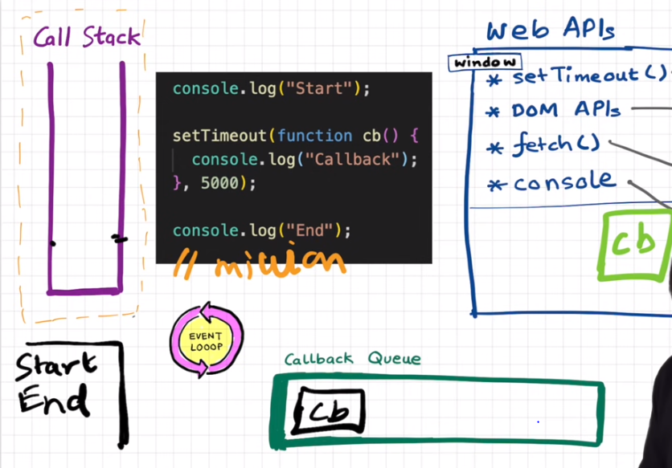

If after the console.log end if there are 1 million lines of cde and if it takes 10sec to execute that. So GCE will not execute the CB and GCE will be busy executing the lines of code. Now eventloop is checking the GCE weather GCE is free or not.and as GCE takes 10 sec . CB will get chance ony after 10 sec but settimeout is ony for 5 sec but it is getting change only after 10 sec.

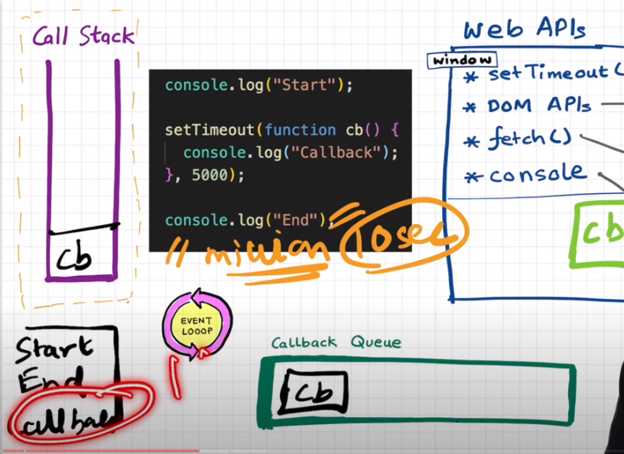

After 10 sec it will execute the CB and will print

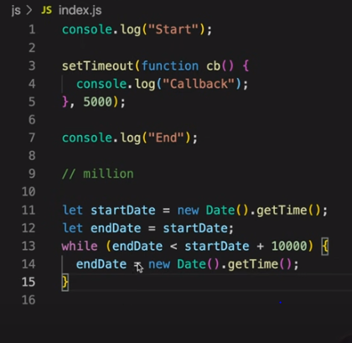

## Higher order functions

A function which takes another function as an argument or returns an another function then it is called as higherorder function.

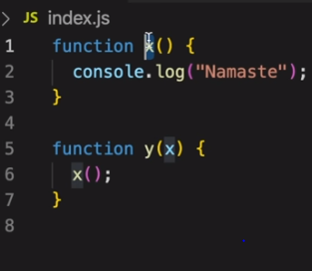

Here is y is the higher order function and x is the call back function.

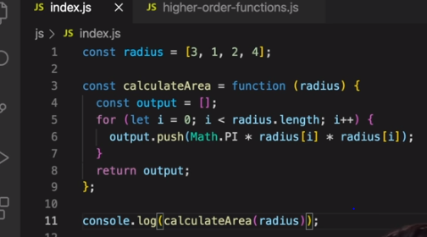

Calculate area of the 4 circles.

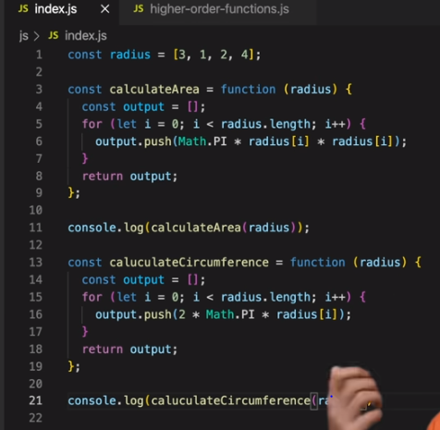

Here for each functioanality new function is created and just formulae is changed.

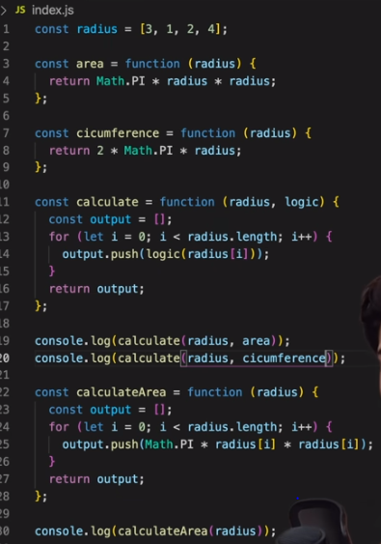

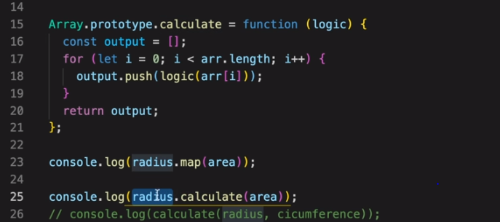

Converting the calculate function as a map.

## Map, filter, reduce

Map-

Map is used to transform an array. It means it takesinput as array and perform some operation on arra and provided output.

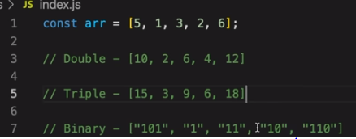

First array is input and other arrays are outputs.

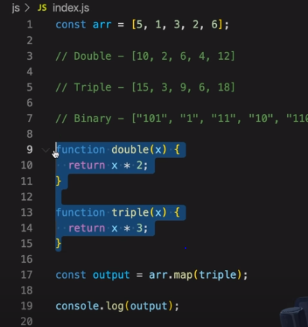

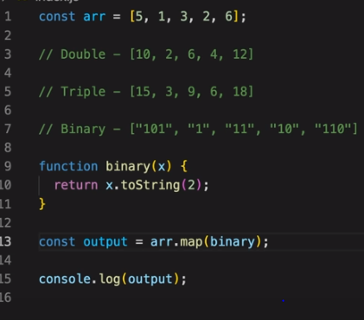

Filter-

Filter is used to filter the values in array.

Like filter even numbers or filter number greater than 4.

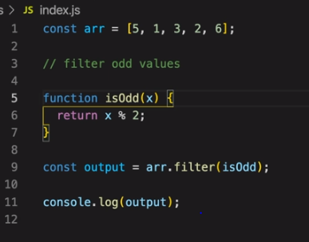

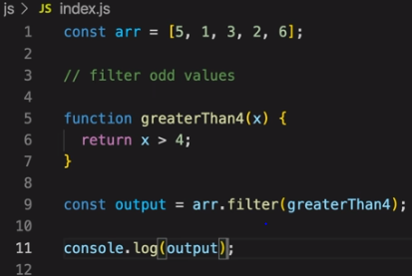

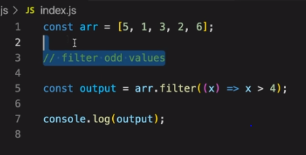

Reduce –

It is used to get the single output.

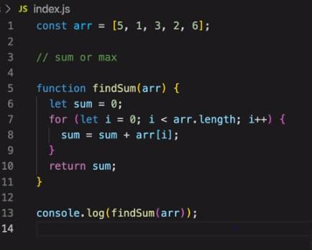

This is the code which is used to calculate the sum of the elements in the array.

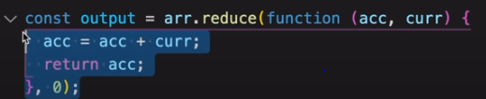

Same code using reduce is written as below. 0 is the initial value and acc is the function and curr is the each value in the array.

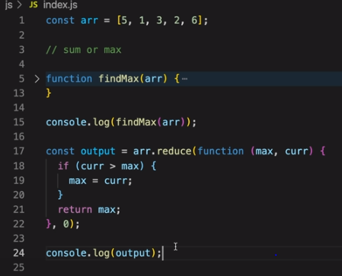

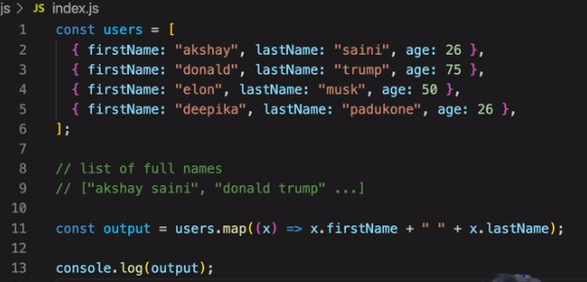

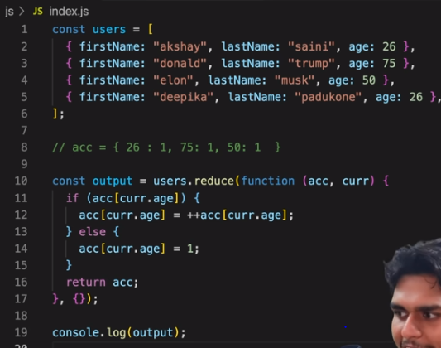

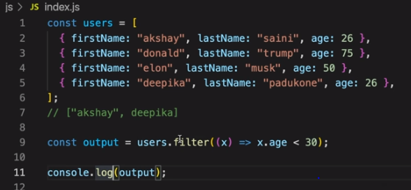

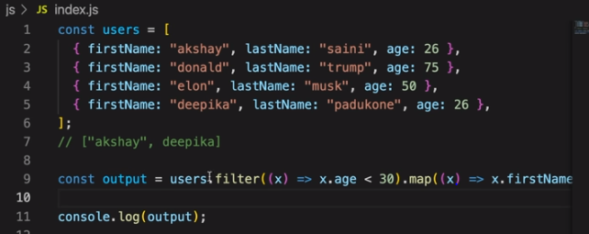

# Callback Hell

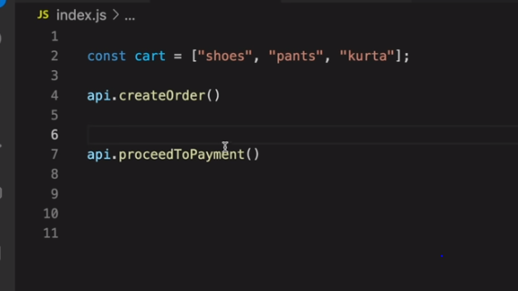

If we need to execute the proceed to payement only after create order is completed.

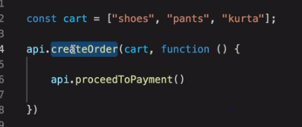

Here by using call back one create order is completed then its responsible is to call proceedtopayment.

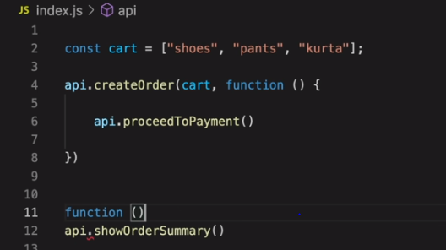

Now again after proceeedtopayment I need to display the details in the UI for that I need to call the showordersummary.

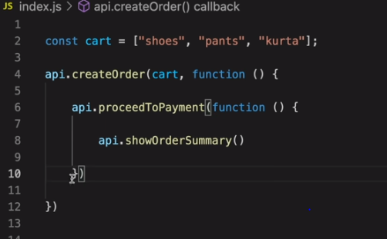

To do that again we need to send the method as a callback to proceedtopayment.

But because of this if we have same functions which need to execute one after other then same kind of callbacks need to created and it will be lot of callbacks and it is callback hell.

And code maintenance is tough with this callbacks structure and it is called as pyramid of doom.

# Inversion of control

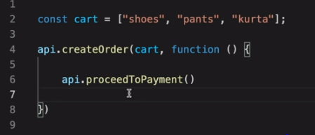

In this case we have passed callback function and giving access to createorder method to call call back method. But we don’t know what happens in the createorder and does our proceedtopayment will execute properly or not.

# Promise

These are used to handle async operations.

Cart is a array which contains items.

Createoder creates orders and returns order id.

Proceedtopayment- after ordering call te proceedtopayment with order ids. To pay.

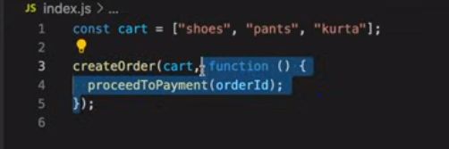

Using callbacks above code is used to call proceedtopayment. But there is an issue called IOC.

To getrid of above issue use the promises.

So when createorder api is called after completing it will return the promise. Promise is an empty object with data value. And data value is the data which api returns (like Json)

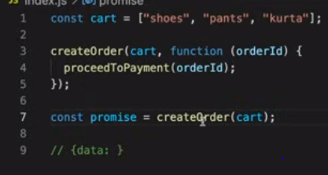

Once the line 7 is executed it will return the promise and that promise will contain the data with undefined.

And the code will goes on executing the other lines after line 7



Now once the createorder is completed like say after 5 sec the order creation is completed then the createorder api will return the data and that will be updated in to the data value in the promise automatically

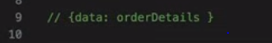

Now once the data is updated in the promise then we can call the callback function.

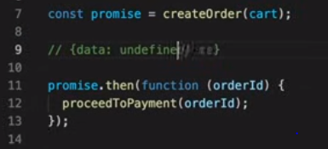

promise.then is used to call the callback functions. Immediately after updating the promise with data then it will automatically call the calllback function. And once data is updated promise will call the call back function only once.

Fetch() - is the service given by the browser where we can call the other apis and get the info.

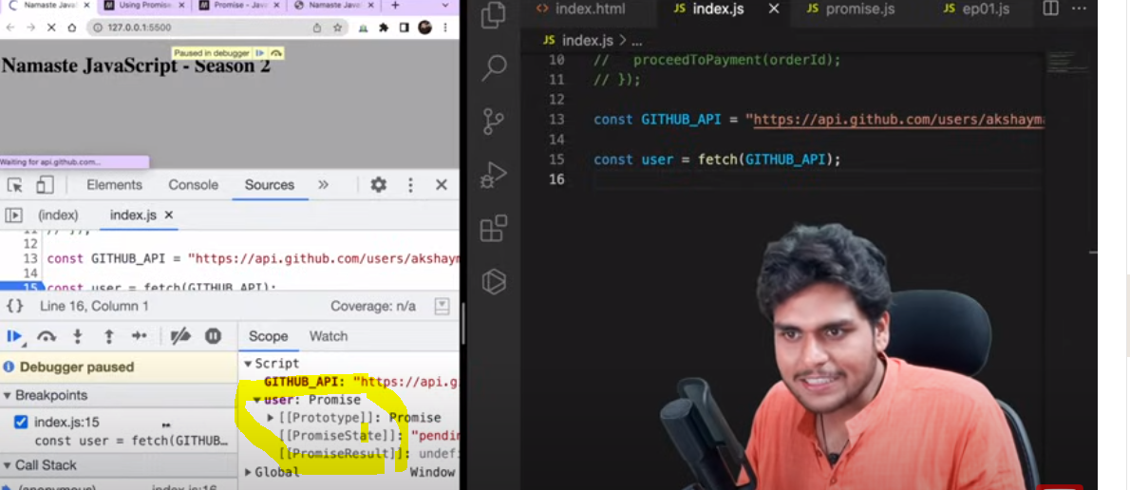

Here fetch will return the promise object.

Primisereesult will store the return data from api.

Promisestatus will save the satus of promise.

Pending is the first status - when api url is called then promise status will be pending.

Fulfilled status – once the api url returns the data and updated in the promise then the status will be updated to fulfilled.

Rejected status -

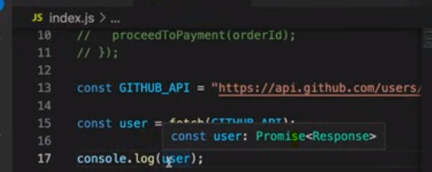

Promise objects are immutable. So we cannot edit the data inside the data object of promise.

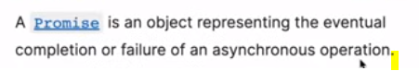

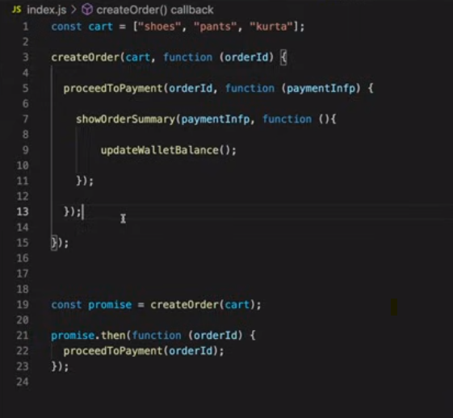

Callback hell- can be solved using promises.

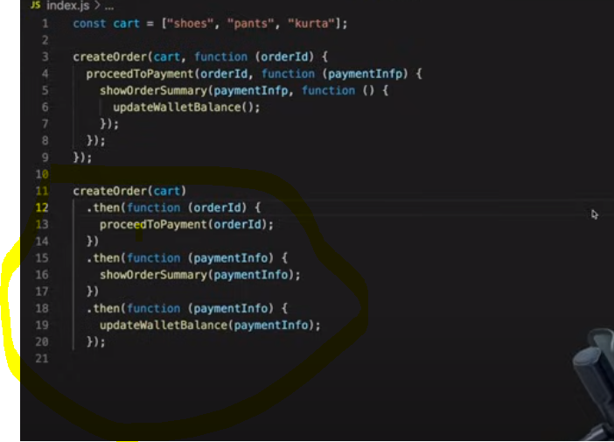

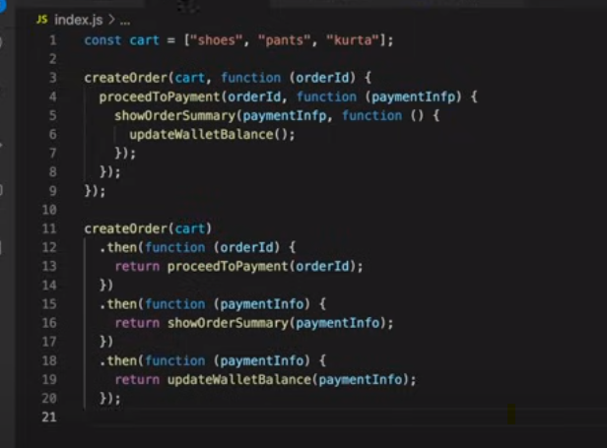

When we chain multiple apis, promises to work e need to return the api as shown above.

## How to create promise

To create promise use new keyword and promise constructor.

Promise constructor will take function as input which contains resolve and reject as parameters. Resolve and reject are the javascript objects.

In the method createorder we will create the promise and this method is called as producer.

We can reject and resolve the promise based on the validations and output.

In below code reject() will just reject the promise when validations fail. We will pass the error through reject.

When all is well means every thing is successful then we will resolve the promise. Once everything is even we will resolve just by calling resolve() and by passing data into resolve as shown below.’

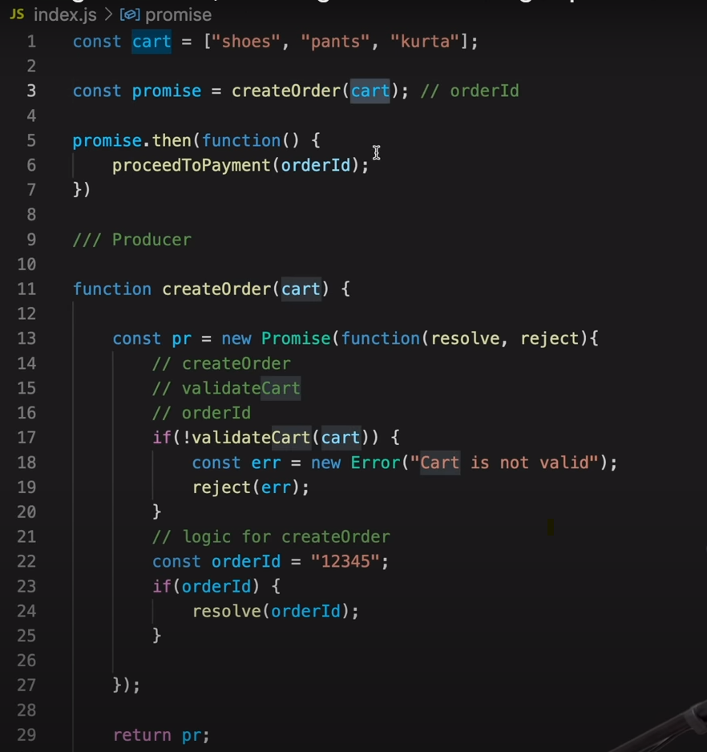

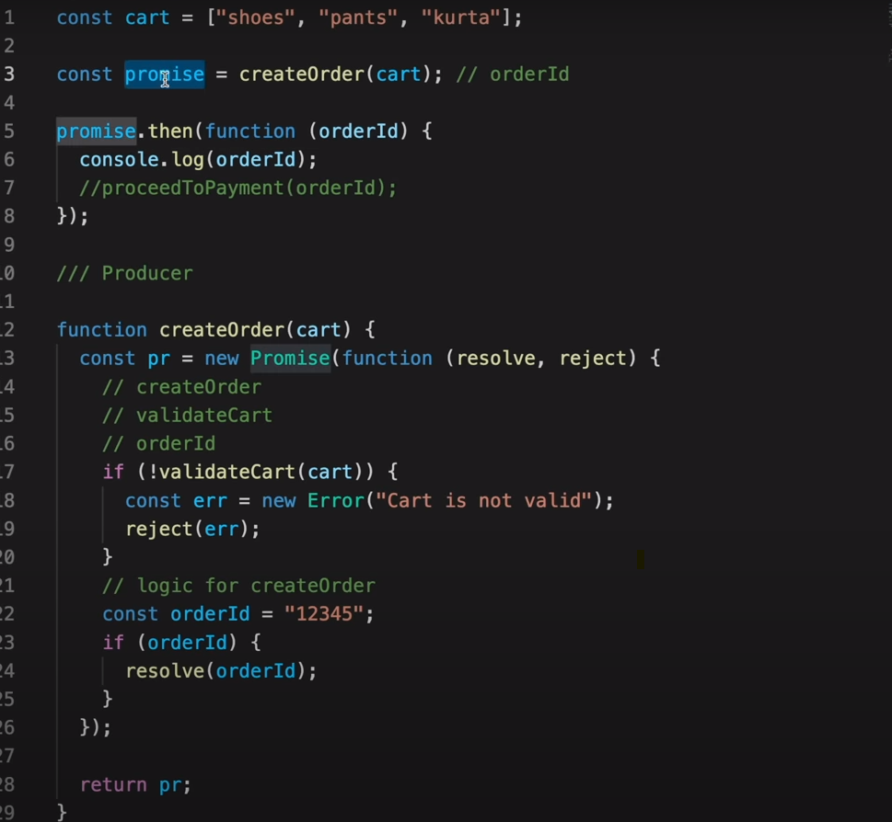

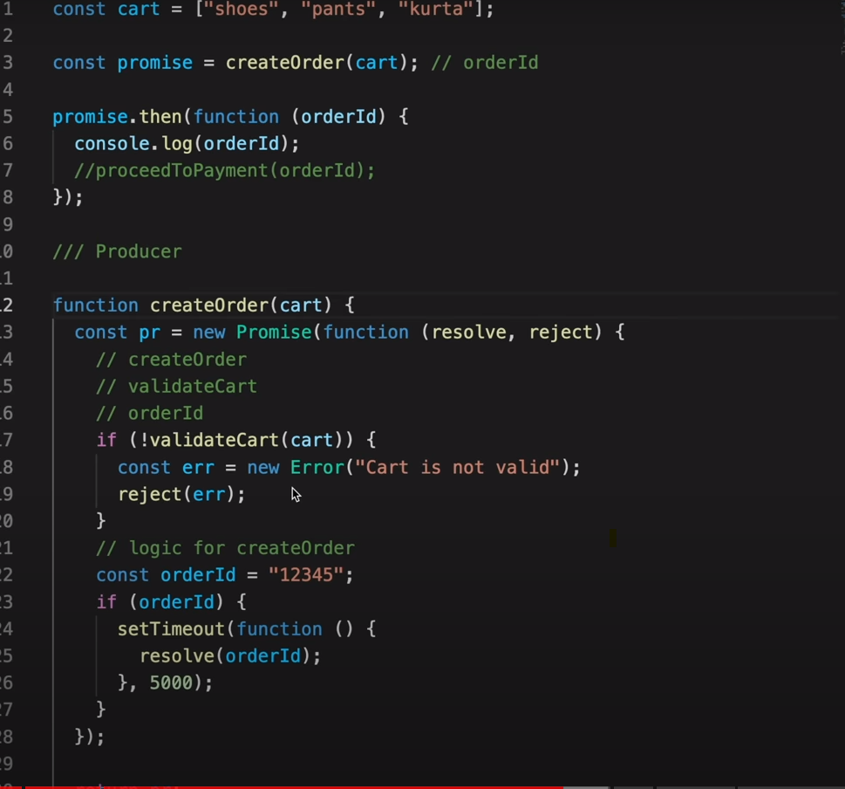

Above code is to return data in to the promise after 5 sec. hen timeout is set the resolve will happen after 5 sec. so data in the promise will be updated after 5sec.

Console.log(promise) - we can see that first promise will be printed and after 5 sec data will be updated.

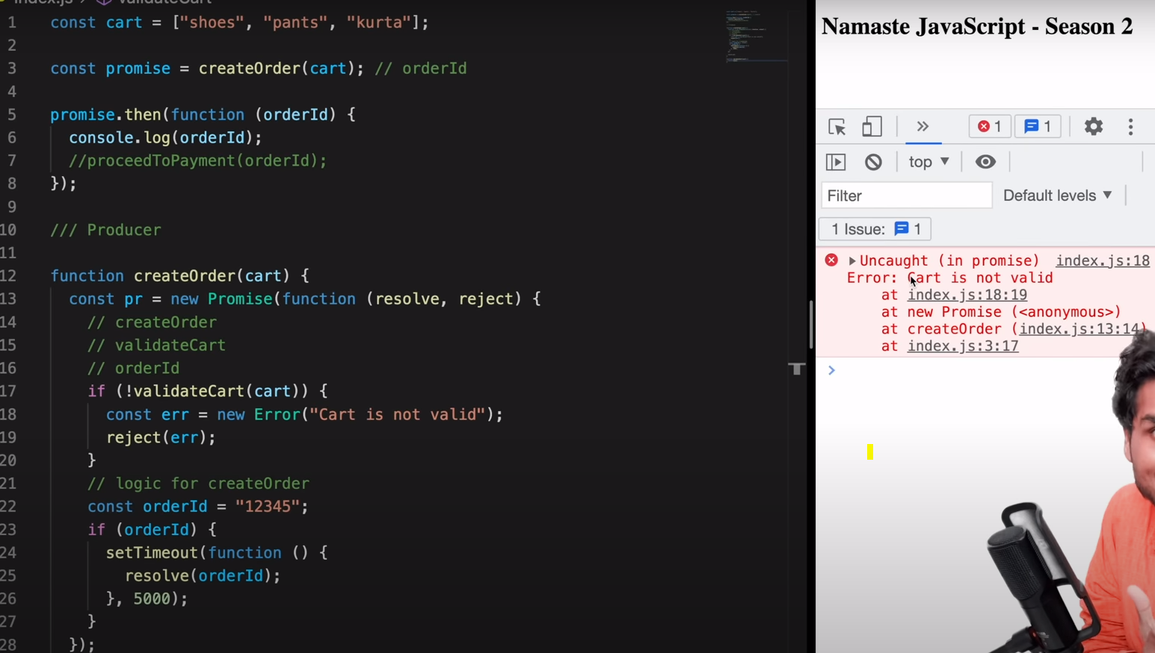

When promise is rejected then error will be dsplayed.

While cosumimg the promise if promise was rejected then use catch to handle the error and in the catch we can also call the call back function samelike when promise is success we have called the proceedto payment method. When promise is rejected we can also call the other callback function in the catch.

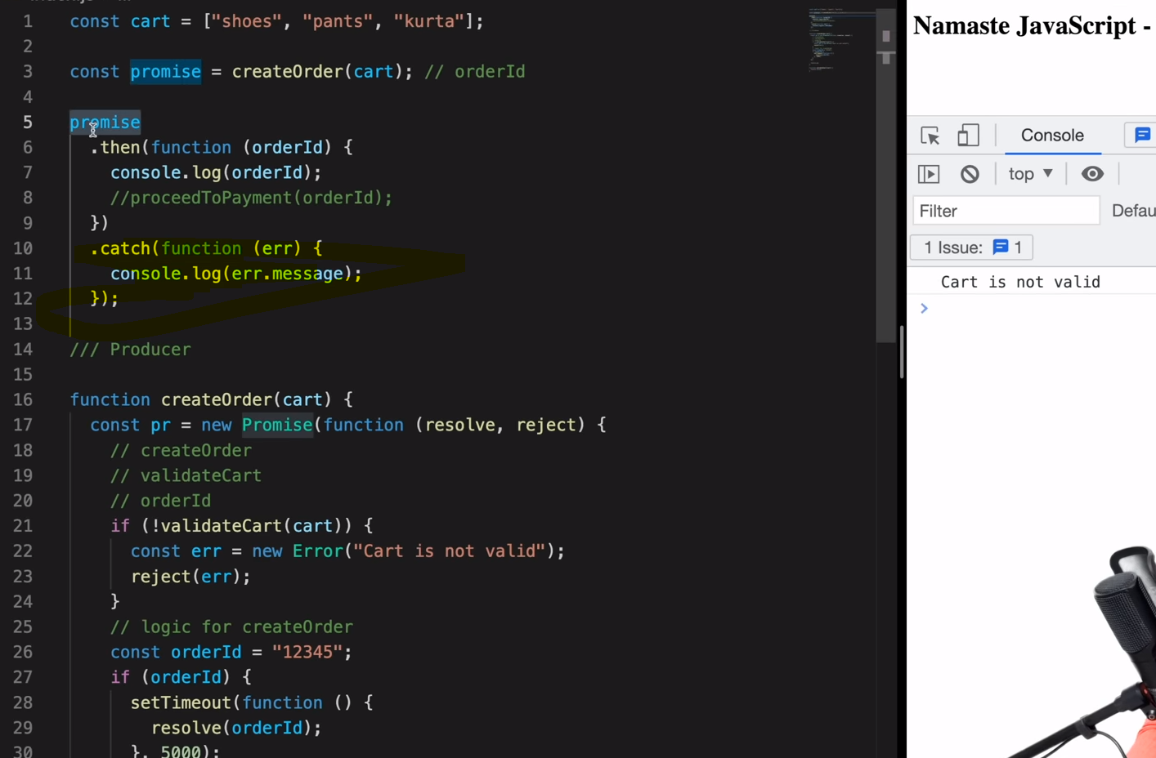

As shown in above code wwhen promise is rejected then catch is used to catch the error.

## Promise chaining

When chaning is done using promise then we can writ only one catch and all the errors of all the primises can be handled in that one catch handling as shown below.

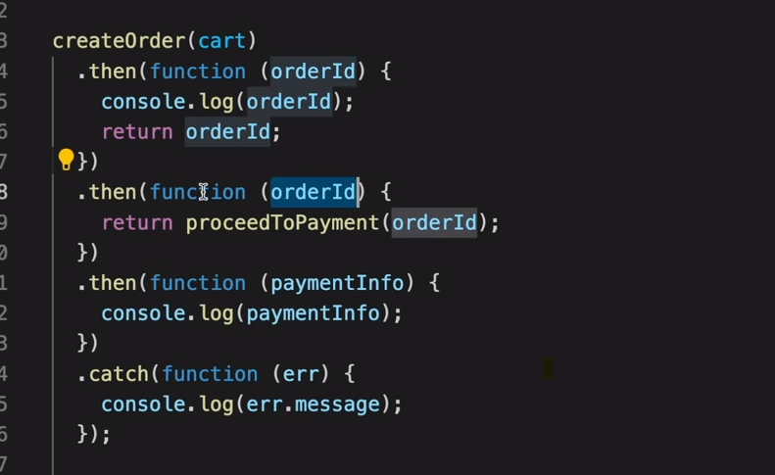

In above case if any exception has occurred in any promise then the next callback function wlllnot be executed and directly goes to the catch and thorows error.

But what if we need to execute other call back even if we got exception then usebeloww code. When catch statemtn is added then that catch will catch the exception from the functions which were above it. And all the below functions exceptions will not be handled by that catch. We need tio write one more catch fr other functions.

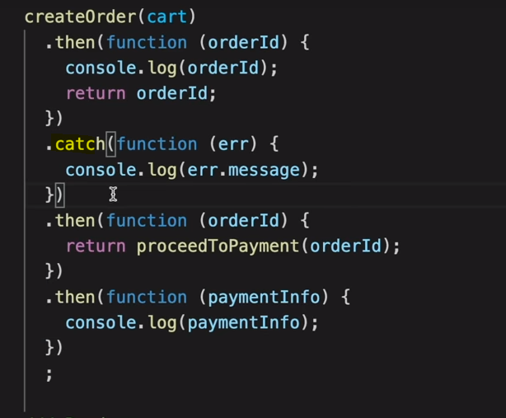

# Promise APIs

**1 promise.all**

if we want to make parallel api calls and get the info. It will handle multiple promises. It will take the promises in the array format.

Promises.all([p1, p2, p3])

If p1 takes 3sec and p2 2 sec and p3 1 sec. so if all are success. So when we call promise.all then th result will have the array with results [val1, val2, Val3]. So final result will take the 3 sec. after 3 sec it will give the result with array. Promise.all will wait till al the apis to finish.

If any of the promise is rejected. As soon as any api is failed then immediately promise.all will give the result as error and error is the outpu of the failed api or promise. Now if any one promise is rejected then all the promises wwill be rejected. It means it will not wait for other promises and will return error.

If one promise is success and other primise wich takes more time than the successed promise is failed then in this case we need the result of succussed promise.

**2 promise.allsetteled**

Promise.allsetteled([p1, p2 , p3])

When we use promise.allsettled then even if one promise is failed then it will wait till other promises completed. Once all the promises are completed then it will return the output of all the promises. As below

[val1, err, val3]

If we need all the results of apis then use promise.allsetteled. else use promise.all

**3 promise.race**

First completes will win it means which ever api completes first that result will get as output.

Promise.race([p1, p2 , p3]) here as P2 takes 1sec and it completes first then result wwill be val2 jus a value not a array.

What if first promise or api is error itmeans P2 is failed then error will be thrown as a result.

**4 promise.any**

it is same as race but it will return the first succussed api or promise. So evenfirst api is got exception then itwill wait till other promise which was success.

So if P3 is rejected then next one in race is P2 wich takes 2 sec then it will return result of P2.

What if all promises falies then it result will be aggregated of all erros. Result will be array of erros [err1, err2, err3].

Ex1

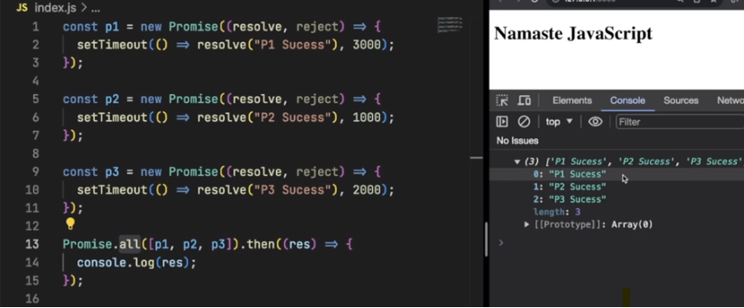

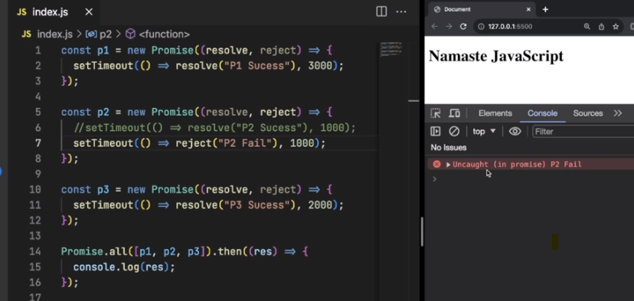

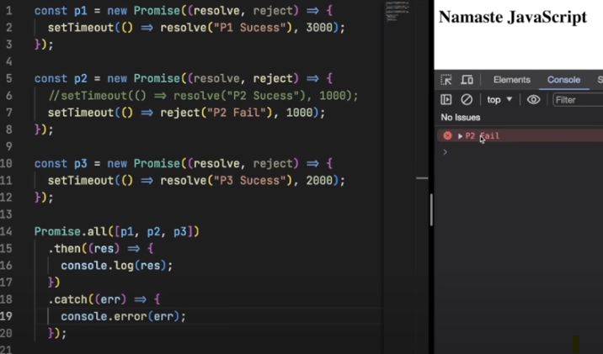

With catch

All settled

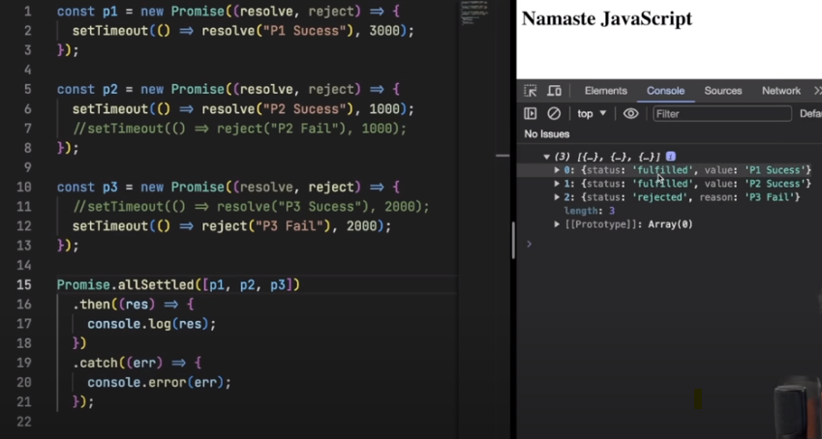

race

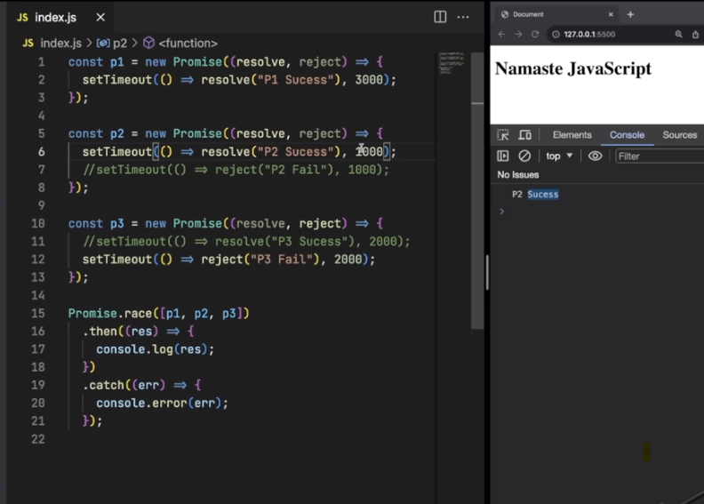

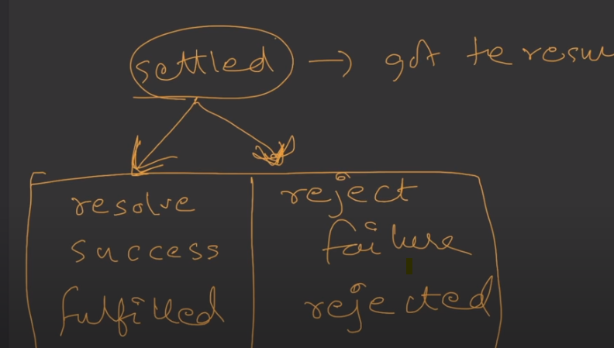

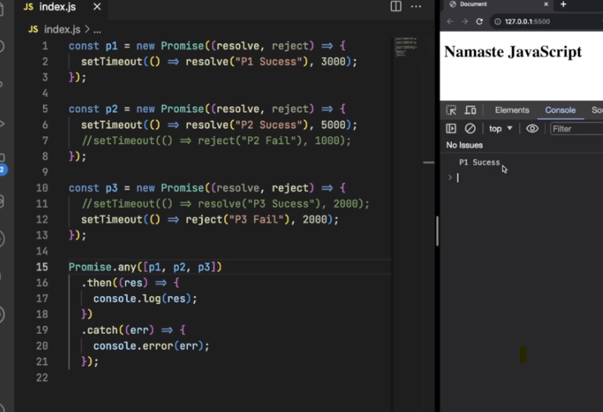

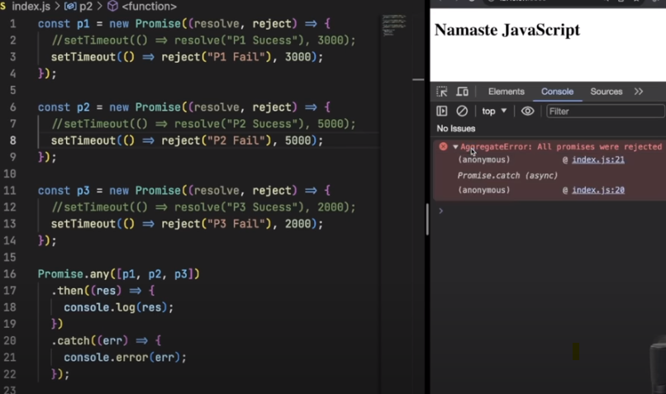

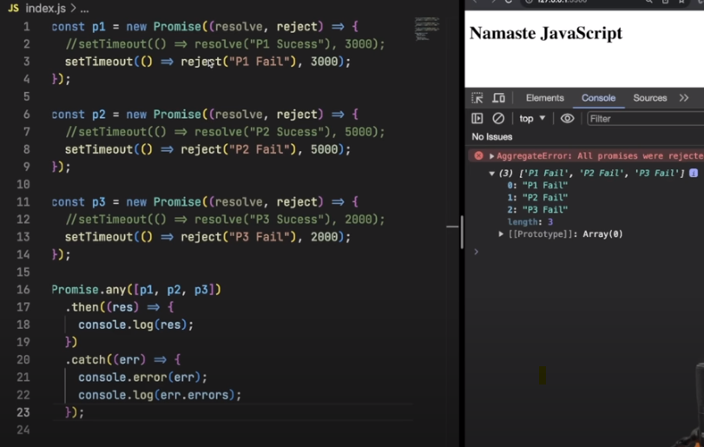

# Async await

## Async

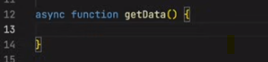

write async infront of the function. This async function will always return promise.

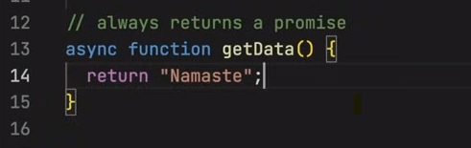

If we return promise inside async function then it is fine. If we don’t return promise as shown above. Then it will wrap the return data into the promise and will return the promise.

At consumer side we can use same way as we use promise .

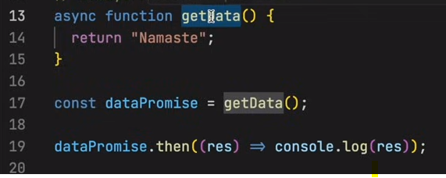

Return promise as shown below.

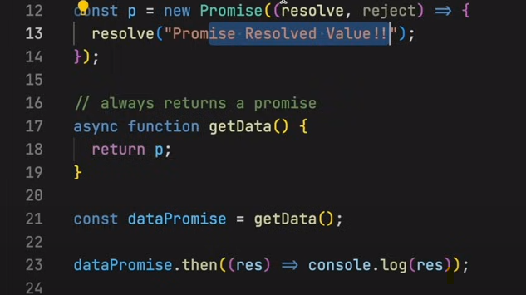

Below commented code is normal way of consuming promise.

And in async function shows the await way of consuming the promise

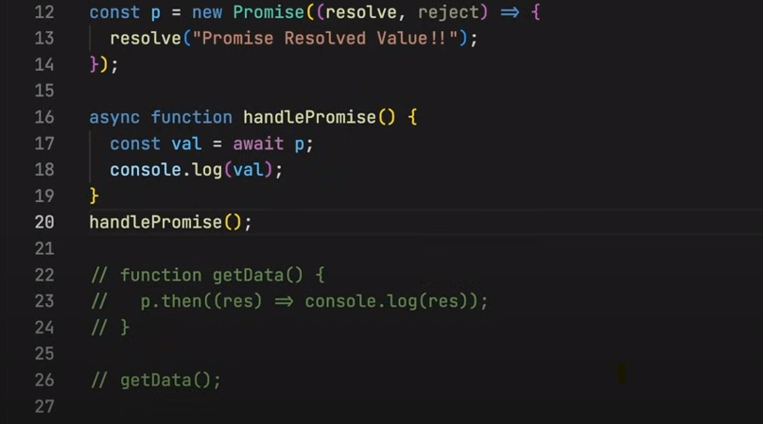

So use await keyword before the promise and save that value in variable and use it .

Await is the key word that is used only in async function.

In below code we are using ormal way of consuming the promise. So when we use nrmal way, then javascript wont wait till the promise is resolved. So in console we can see first namastejavascript is prited and next promise resolved.

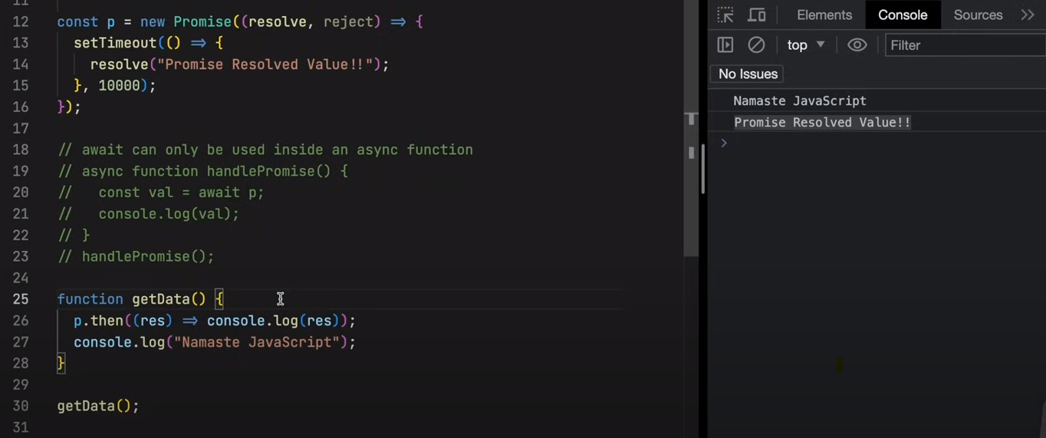

So in above code js is not waiting. But js to wait till the promise is resolved then we need to use the await.

In below code js will wait until the promise is resolved and then will go to next line.

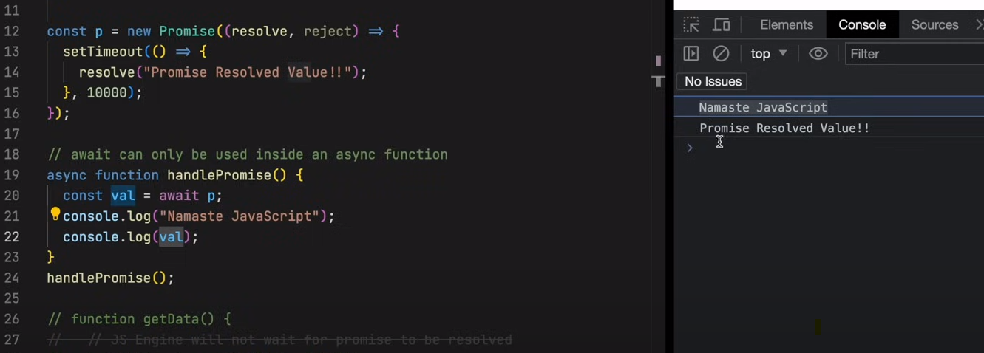

In below code we are using await multiple times using same promise p, but the result is wwhen js is executing first await it waited for 10 sec , but for the second await it didn’t waited and printed the result of both promises at a time.

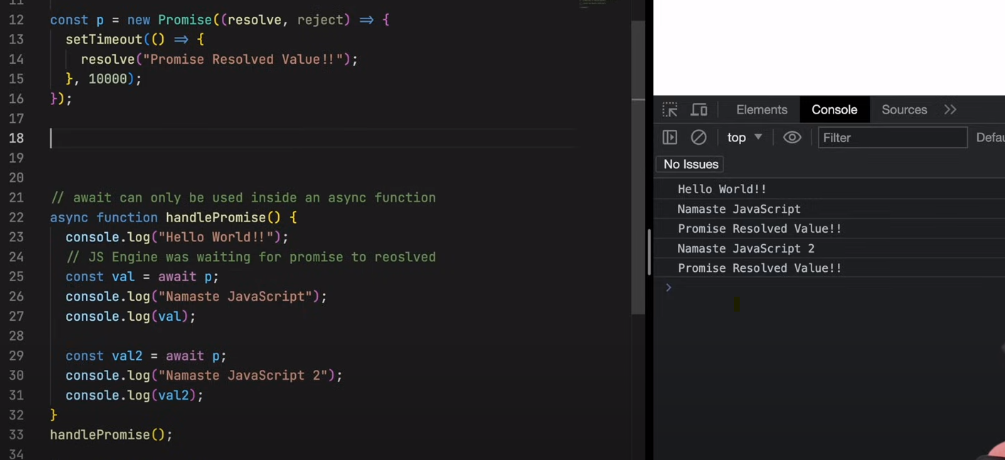

Now we have created two promises P1 and P2 and made p1 to wait for 10sec and P2 for 5sec and in code first P1 is called using await and next P2 is called using await. Now In this case also js is waited for 10 sec and printed the result of both promises at once after 10 sec.

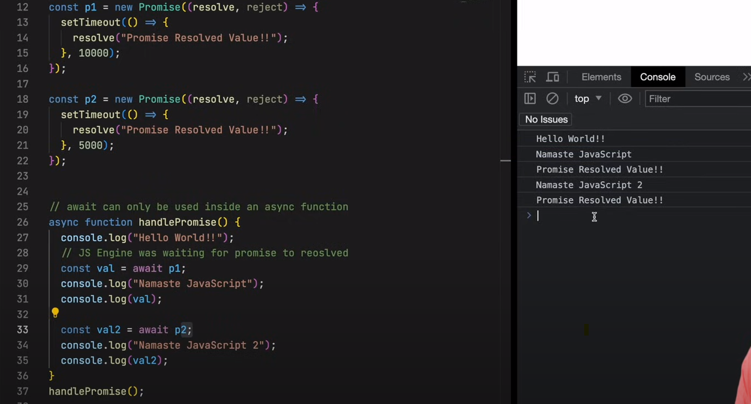

Now the timing of the p1 and p2 is reversed it means P1 is 5 sec and P2 is 10sec. in this case first await is waited for 5 sec and then got printed result of P1 and then js is waited for more 5 sec and printed the result of p2.

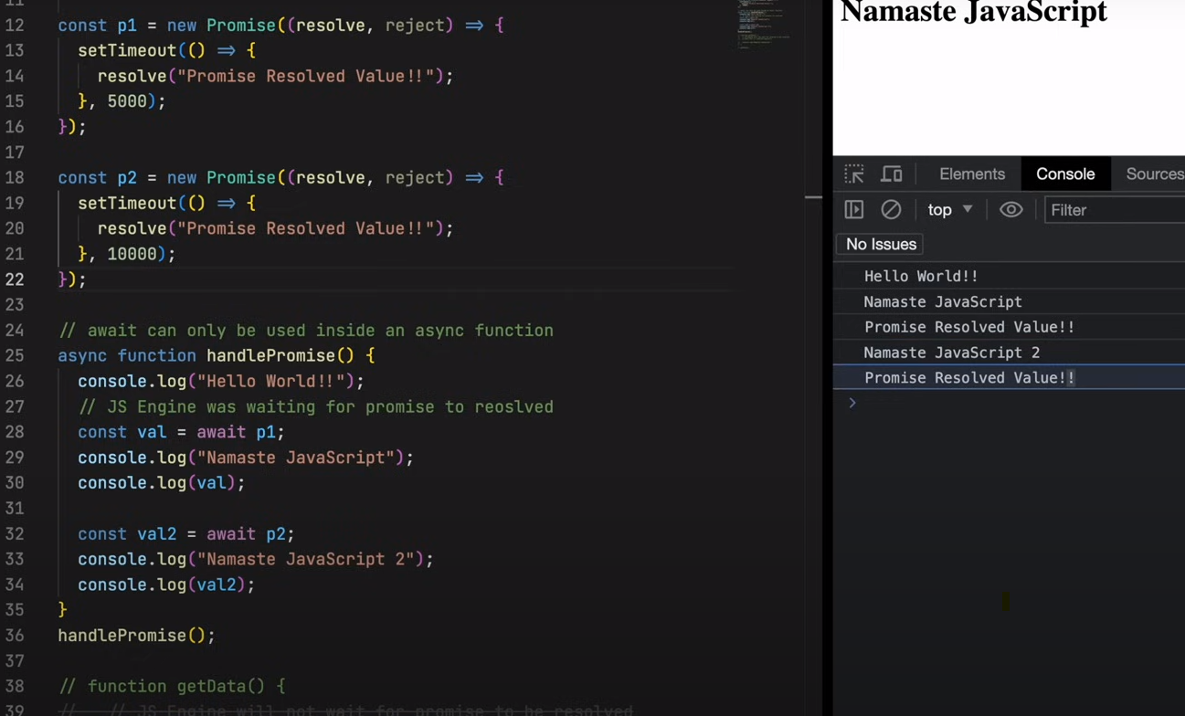

Now how the code actually works.

First call stack is empty.

And when handlepromise is called then it will see that there are two promises and it don’t know the time of the each promise will take.

The handlepromsie will enter into callstack and start executing the code inside function.

Wwhen js goes to line 28 it will see that await keyword and the handlepromise will be removed from the calstack because js will not wait. It means js will suspend the function handlepromise. Now js will wait until the P1 is resolved and once p1 is resolved then again the handlepromise will resume and this time it will start from where it was suspended last time. Now again it will check eather p2 is resolved or not so p2 is not resolved the again handlepromiseis suspended. And once p2 is completed then again handlepromise will resumefrom where it is suspended.

In second case if P1 is having 10sec and P2 is having 5sec.

So while executing the await. Only function is suspended but Js is not waiting . js will execute if it gets anything.

### Fetch

Fetch will return the promise.

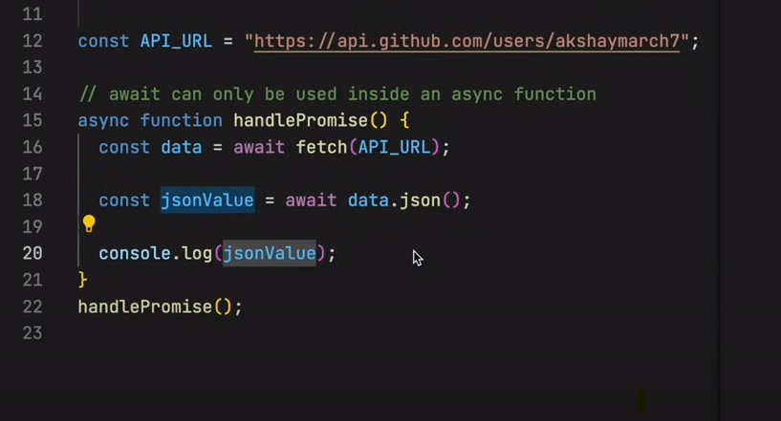

Error handling in async and await. Because in normal call wwe used .catch

But in async await we need to wrap the code in to try catch

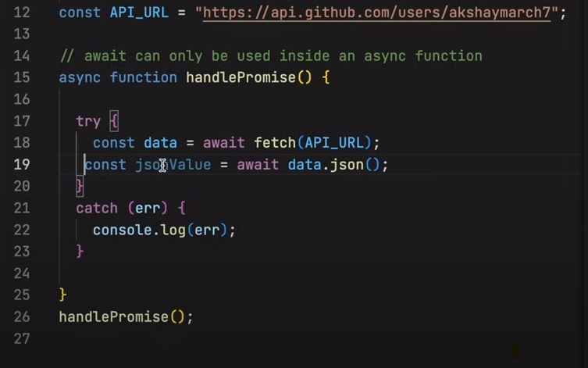

Another way is as below. As async function return promise. We can handle catch at the calling function.

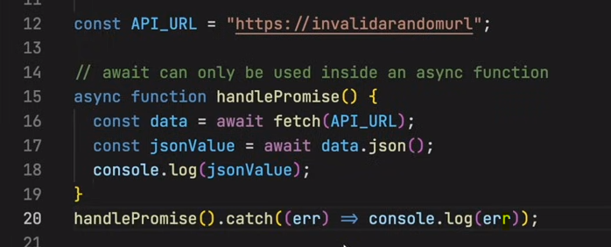

Async/awit or promise.then

When we use Async/Await js will usully use promise.then in the backend.

Both are better we can use any.